***Practice Lab 2 Solution***

use university;

create table city(

cid INT NOT NULL auto_increment,

cityname varchar(20) NOT NULL,

PRIMARY KEY(cid)

);

insert into city(cityname)

values('Multan'),

('Sargodha'),

('Lahore'),

('Faisalabad'),

('Khanewal');

create table student(

id int not null auto_increment,

name varchar(20) not null,

marks int not null,

age int not null,

gender varchar(1) not null,

city int not null,

primary key (id),

foreign key(city) references city(cid)

);

insert into student(name,marks,age,gender,city)

values("Ali",85,19,"M",1),

("Ahmad",33,21,"M",2),

("Majid",64,18,"M",3),

("Waseem",93,20,"M",1),

("Jasim",72,22,"M",5),

("Waqar",76,23,"M",3);

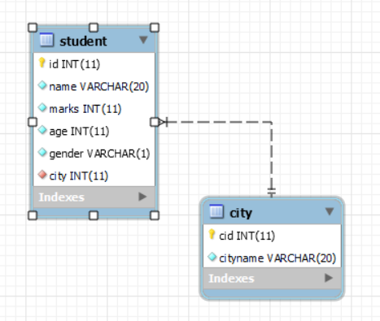

**Inner join**

select * from student inner join city

on student.city= city.cid;

Aliases

select * from student as s inner join city as c

on s.city= c.cid;

**on look at the required colum names**

select s.id, s.name,s.marks,s.age,s.gender,c.cityname

from student as s inner join city as c

on s.city= c.cid;

where c.cityname="Lahore"

Left join

SELECT * FROM student left join city

on student.city=city.cid;

Right join

SELECT * FROM student right join city

on student.city=city.cid;

**Cross Join**

SELECT * FROM student cross join city